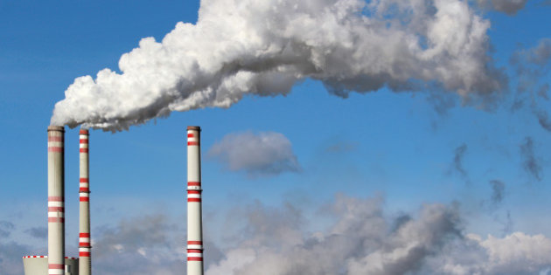

Engineering Economics Course Project

Carbon Taxes to minimize cO2 emissions in a micro-grid

Prepared for ECON74000, Winter 2018

David Eelman (6365316)

Stanislav Rashevskyi (7028178)

Thomas Abdallah (7141518)

Contents

Introduction 2

Problem Statement 3

Assumptions 3

Economic Analysis 3

Levelized Cost of Energy (LCOE) 3

Present Worth Analysis 4

Incremental Internal Rate of Return Analysis 7

Equivalent Annual Cost Analysis 8

Factors Missing From Analysis 8

Appendix A – Present Worth Analysis Calculations 10

Appendix B – Incremental Internal Rate of Return Analysis Calculations 12

Bibliography 14

# Introduction

This report will identify the best energy production option and associated carbon tax price to incent the adoption of renewable energy sources and minimize the use of diesel fuel generation in a micro-grid application for a remote Northern Ontario community. The analysis will consider four energy production options (Table 1) that could be purchased and become operational in 2019. These options include a mix of wind, solar, and diesel energy production. The analysis for this project will consider the present worth, the incremental internal rate of return, and the equivalent annual cost for each energy production option. A tax (dollar per kilogram of CO2 emissions) will be proposed that shall minimize diesel fuel generation and increase the feasibility of the options that include renewable energy sources. The same analysis will be performed using the tax rules of the United Kingdom to provide comparison on the feasibility of the project in that country.

Table - Generation Options

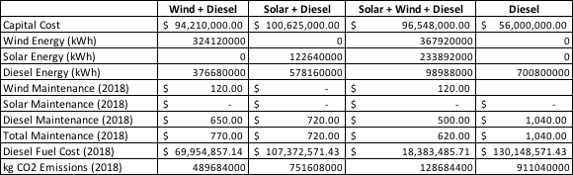

# Problem Statement

This report will determine an appropriate CO2 tax to be applied that will minimize the use of diesel fuel generation in a theoretical micro-grid application in Northern Ontario and compare the feasibility of this project to the same project if it were undertaken in the United Kingdom.

### Assumptions

1. Yearly maintenance cost increase is 5% of the previous year’s maintenance cost.
2. Yearly CO2 emissions increase is 2% of the previous year’s CO2 emissions.
3. Yearly diesel fuel cost increase is 2% of the previous year’s diesel fuel cost.
4. No tax credits or other government incentives for any generation option.
5. 100% utilization rate for all generation options, i.e. running at maximum power output 24 hours a day, 365 days a year.
6. Same cost of financing for all generation options.

# Economic Analysis

### Levelized Cost of Energy (LCOE)

The concept of LCOE represents the total cost per unit of energy of constructing and operating a power plant over its lifetime (U.S. Energy Information Administration, 2018). LCOE provides a convenient mechanism for comparing the competitiveness of different generation technologies. In this report we only consider the capital costs, fuel costs, and maintenance costs when evaluating each generation option, although a full LCOE analysis would include the cost of financing, operation, and utilization rates for each generation option.

### Present Worth Analysis

The present worth of each option from Table 1 was conducted utilizing the corporate tax rate in Canada of 36.1% (Pearson Canada, Inc., 2017), a before-tax MARR of 20%, and a Capital Cost Allowance (CCA) of 20% (Class 8). After-tax MARR is calculated to be 12.78% as shown below. option.

$${MARR}_{after-tax}= {MARR}_{before-tax}*\left(1-tax rate\right)=20\%*\left(1-0.361\right)=12.78\%$$

The Capital Tax Factor (CTF) is calculated as shown below.

$$CTF=1- \frac{\left(tax rate\right)*\left(CCA\right)*\left(1+ \frac{{MARR}_{after-tax}}{2}\right)}{\left({MARR}_{after-tax}+CCA\right)*\left(1+{MARR}_{after-tax}\right)}= 0.792$$

The present worth of the capital cost for each generation option is calculated as follows.

Table - Present worth of capital cost



The present worth for all annuities associated with each generation option are calculated as follows. Table 3 shows the present worth of all annuities over a 20 year period for each option. Appendix A shows the Excel calculations used to generate these values.

Table - Present worth of annuities



The total present worth for each option is sum of the present worth of the annuities and the present worth of the capital cost. Table 4 shows the total present worth after taxes for each option with no carbon tax implemented.

Table - Total Present Worth



The Wind + Solar + Diesel option as the highest total present worth even without the inclusion of a carbon tax. When applying a carbon tax, the present worth of all projects is reduced, but the Wind + Solar + Diesel project is still the most valuable. Therefore, based on the present worth analysis no carbon tax is needed to incent the adoption of a renewable energy project.

Figure - Present Value vs Carbon Tax Rate

If we consider the same analysis conducted in the United Kingdom with a tax rate of 28% (after-tax MARR of 14.4%) and using straight-line depreciation to determine the tax savings on the capital investment we see the same results with no carbon tax being required.



Figure - Present Value versus Carbon Tax Rate in the United Kingdom

### Incremental Internal Rate of Return Analysis

Analysis begins by calculating the incremental cash flows for each option without a carbon tax implemented (Appendix B). The Diesel only option is selected to begin with as it has the lowest capital cost. The option with the next lowest capital cost is Wind + Diesel generation. The incremental IRR for this option over Diesel only is 200.9% which is greater than the after-tax MARR so this option is chosen. The option with the next lowest capital cost is Wind + Solar + Diesel generation. The incremental IRR for this option over Wind + Diesel is $2787.10 which is much greater than the after-tax MARR so this option is chosen. The incremental cash flows for Solar + Diesel over Wind + Solar + Diesel are all negative so this option is rejected. Therefore, by the incremental IRR method the Wind + Solar + Diesel generation option should be selected and no carbon tax is necessary.

If we consider the same analysis conducted in the United Kingdom with a tax rate of 28% (after-tax MARR of 14.4%) and using straight-line depreciation to determine the tax savings on the capital investment we also find that no carbon tax is necessary to incent the adoption of renewable generation options as the Wind + Solar + Diesel option is chosen through the incremental IRR method with no carbon tax applied.

### Equivalent Annual Cost Analysis

The equivalent annual cost (EAC) of each option from Table 1 was conducted before-tax, with a MARR of 20%, for a 20-year period, including all assumptions stated above in the Assumptions section of the report.

The general formula for EAC calculation is shown below.

${EAC}_{total}={EAC}_{capital cost}+{EAC}_{maintnance}+{EAC}_{diesel cost}+{EAC}_{CO2 tax cost}$,

where:

$${EAC}_{capital cost}=Capital cost*(A\backslash P, MARR, 20)$$

$${EAC}_{maintnance}=Total maintnance+maintnance raise* (A\backslash G, MARR, 20)$$

$${EAC}_{diesel cost}=Diesel cost* \left(P\backslash A,diesel inflation, MARR,20\right)*(A\backslash P, MARR, 20)$$

$${EAC}_{CO2 tax cost}=CO2 tax cost* \left(P\backslash A,CO2 output raise, MARR,20\right)*(A\backslash P, MARR, 20)$$

shows the EAC results before taxes for each option with none and 0.20 $/kg of carbon tax. Appendix B shows the Excel calculations used to generate these values.

Table - EAC calculations for each option



The Wind + Solar + Diesel option has the lowest equivalent annual cost even without the inclusion of a carbon tax. When applying a carbon tax, the EACs of all projects is increased, but the Wind + Solar + Diesel project is still the most valuable. Therefore, based on the EAC analysis no carbon tax is needed to incent the adoption of a renewable energy project.

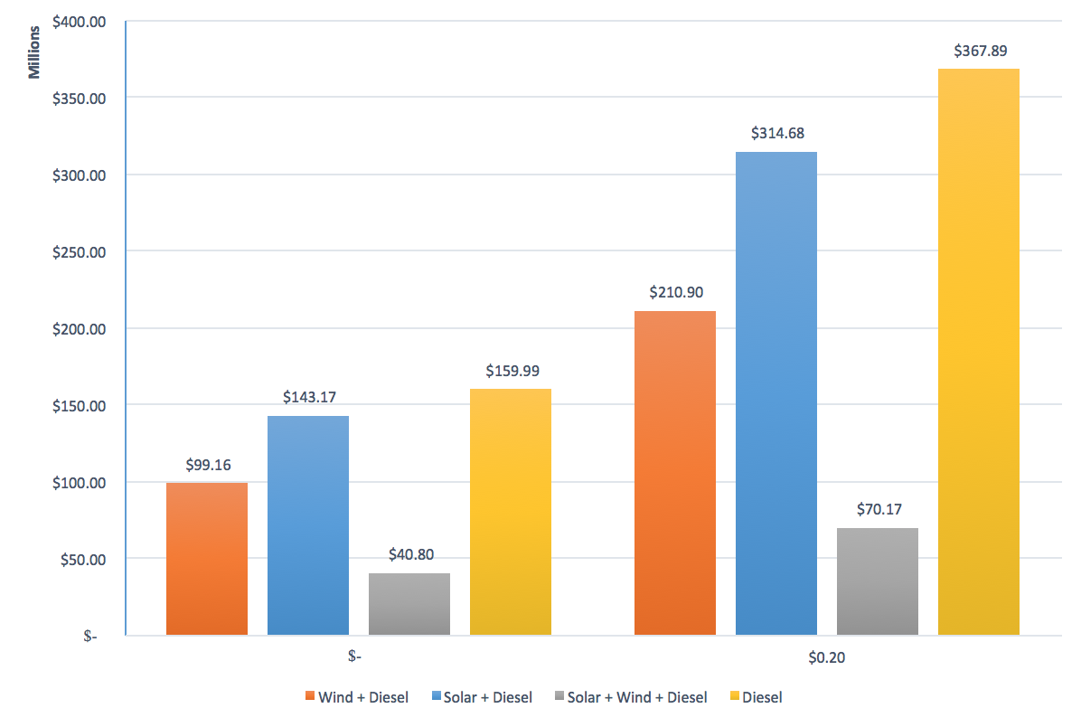

Figure - EACs vs Carbon Tax

### Factors Missing From Analysis

This analysis does not consider any government incentives for renewable projects such as tax credits for renewable projects or discounted financing options which could help to reduce the cost of the proposed carbon tax. This analysis only considers the maintenance and fuel costs for each plant type but does not account for any other operating costs which may impact the total cost of each plant. This analysis only considers carbon produced during the operation of each plant type and does not account for the carbon produced when manufacturing the plant.

# Recommendations & Conclusion

In conclusion, based on our analysis no carbon tax is necessary to incent the adoption of renewable generation options for this project. Our assumptions of a 100% utilization rate and no other government incentives simplify the analysis but may not be representative of the conditions experienced during actual implementation.

# Appendix A – Present Worth Analysis Calculations

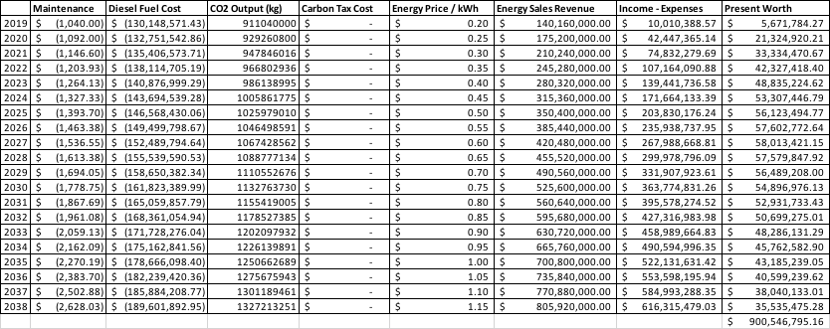

Figure - Present worth of annuities, Diesel Option

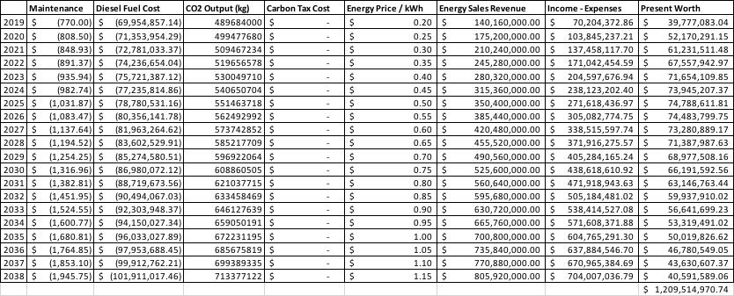

Figure - Present worth of annuities, Wind + Diesel Option

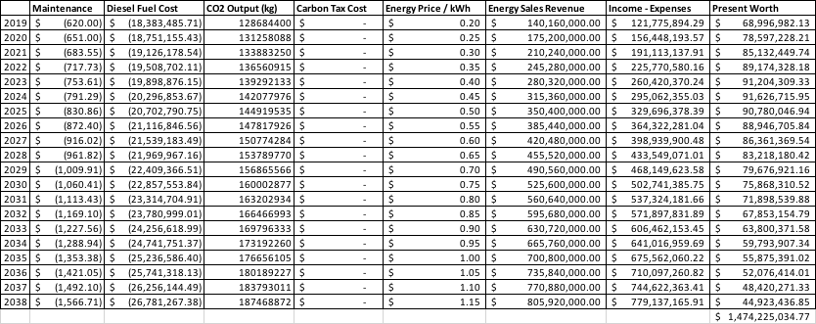

Figure - Present worth of annuities, Solar + Wind + Diesel Option

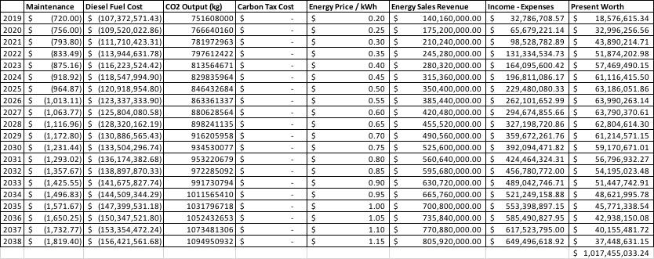

Figure - Present worth of annuities, Solar + Diesel Option

# Appendix B – Equivalent Annual Cost Analysis Calculations

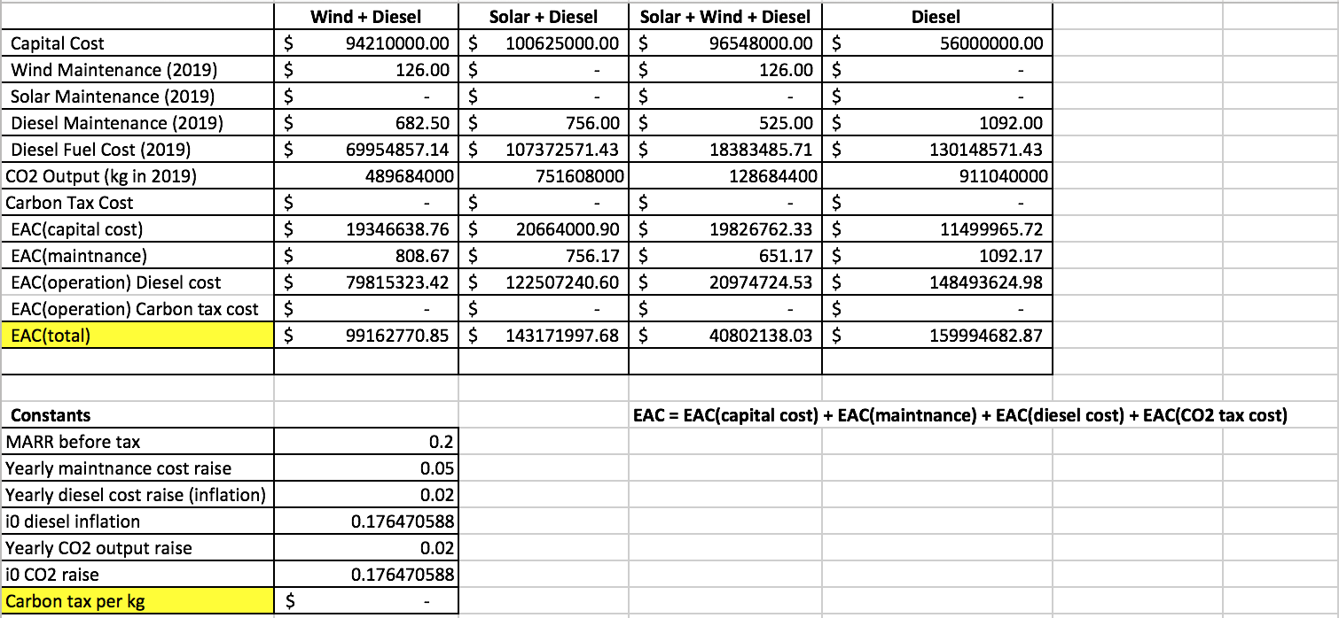

Figure - EAC with CO2 tax of 0$/kg

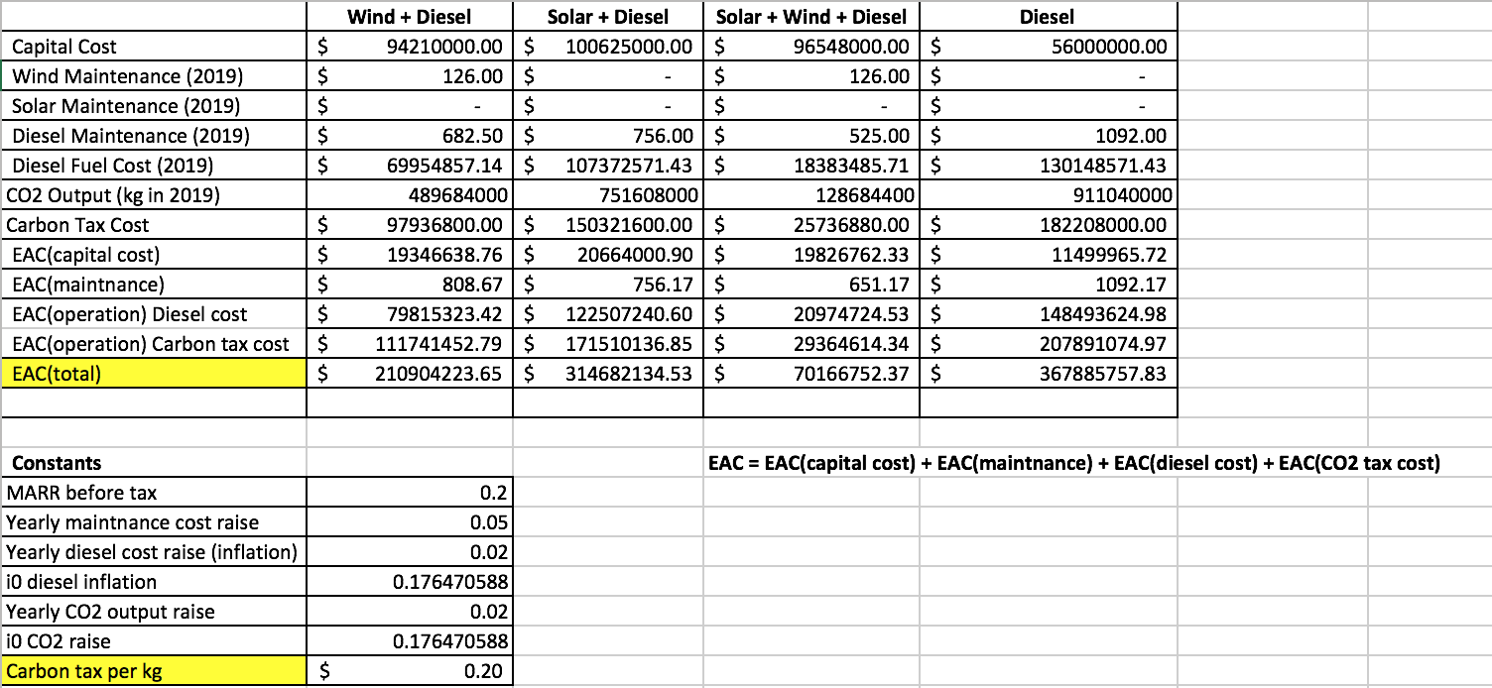

Figure - EAC with CO2 tax of 0.2$/kg

# Appendix C – Incremental IRR Analysis Calculations

|  |  |
| --- | --- |
| Figure - Incremental IRR for Wind + Diesel vs. Diesel, No Carbon Tax | Figure - Incremental IRR for Wind + Solar + Diesel vs. Wind + Diesel, No Carbon Tax |
| Figure 12 - Incremental IRR for Solar + Diesel vs. Wind + Solar + Diesel, No Carbon Tax | Figure - Incremental IRR for Wind + Diesel vs. Diesel, No Carbon Tax, UK |
| Figure - Incremental IRR for Wind + Solar + Diesel vs. Wind + Diesel, No Carbon Tax, UK | Figure - Incremental IRR for Solar + Diesel vs Wind + Solar + Diesel, No Carbon Tax, UK |

# Bibliography

Pearson Canada, Inc. (2017). *Engineering Economics, Sixth Edition.* Pearson Canada, Inc.

U.S. Energy Information Administration. (2018). *Levelized Cost and Levelized Avoided Cost of New Generation Resources in the Annual Energy Outlook 2018.* U.S. Energy Information Administration.